***Edited version: I forgot to discuss about high pass and low pass filtering.***

**Homework: (2 points)**  
1. Discuss the effect of repeatedly applying the following type of filters on the center of an image. Suppose the  
kernel will not reach the image boundaries and thus the effect on them is not considered.  
a. Mean filter,  
b. Median filter,  
c. Low-pass filter,  
d. High-pass filter.

Answer:

Mean filter: we have bluer picture. If we use filter3*3 the second time it similar that we used 3*3 with different value. Absolutely the second one is preferable and have more details.

Median filter: It seems that by adding multiple times median filter we have smother image. Because once you applied a filter (for example3*3) in median filter it sort 9 neighbors of center and put the median instead. In the second time the values are somehow sorted and the difference is not noticeable but in comparison to the first time we have smother image.

Note: We should also add zero around around photo (padding).

|  |  |  |  |  |  |  |  |  |  |
| --- | --- | --- | --- | --- | --- | --- | --- | --- | --- |
| |  |  |  | | --- | --- | --- | | 50 | 57 | 90 | | 14 | 102 | 2 | | 29 | 107 | 11 | |

|  |  |  |  |  |  |  |  |  |  |
| --- | --- | --- | --- | --- | --- | --- | --- | --- | --- |
| |  |  |  | | --- | --- | --- | | A | B | C | | D | 50 | E | | F | G | G | |

High pass filter: the emphasis on edges and details will be more. Depends on noise it will reduce or become sharper and sharper.

Low pass filter: we lose many information in first applying. In the second one we want to apply again low pass filter to an image which lost many information in first filtering. Finally we have a smother image with less noises.

2. Prove that by adding Gaussian noise to an image, the noise variance is reduced.

Answer:

Base on page 7 on slides:

Consider a noisy image: g(*x*, *y*) = *f* (*x*, *y*) +η(*x*, *y*) Gaussian Noise (mean =0)

$$\overline{g}(x,y)=\sum_{i=1}^{k}{g_{i} (x,y)}$$

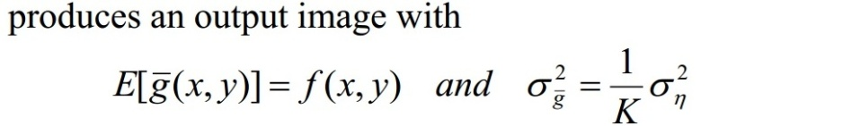

So as K increase the variance of output variance will increase